* **Title**: Fake News Detection Using Naïve Bayes Classification
* **Name**: Onkar Dagadu Kumbhar
* **Course**: Machine Learning and Data Science
* **Date of Submission**: 20th Feb. 2024

**ABSTRACT**

The project "Fake News Detection Using Naive Bayes" outlines a machine learning project focused on developing a fake news detection tool using the Naive Bayes algorithm. Here are key details from the presentation:

**1. Problem Statement and Goal:**

- Problem: The project addresses the spread of fake news, a critical issue in digital society with implications for public discourse, decision-making, and social trust.

- Goal: To create an effective tool for detecting fake news online, leveraging the Naive Bayes classifier.

**2. Methodology:**

- Data Collection: Uses the "Fake and Real News" dataset from Kaggle.

- Data Preprocessing:

- Handling missing values.

- Encoding categorical variables.

- Feature scaling.

- Concatenating real and fake datasets with appropriate labeling.

- Model Development:

- Training the Naive Bayes model.

- Hyper parameter tuning using Grid Search or Random Search.

**3. Evaluation Metrics:**

- Accuracy: Proportion of correct predictions.

- Precision: Correctly predicted positive instances out of all positive predictions.

- Recall: Correctly predicted positive instances out of all actual positive instances.

- F1-score: The harmonic mean of precision and recall for balanced performance assessment.

**4. Conclusion and Future Considerations:**

- The project demonstrates the Naive Bayes classifier's viability in detecting fake news.

- Future research could consider more advanced algorithms, contextual analysis, and adapting to evolving fake news techniques【4†source】.

**INTRODUCTION**

* **Background**

Social media for news consumption is a double-edged sword. On the one hand, its low cost, easy access, and rapid dissemination of information lead people to seek out and consume news from social media. On the other hand, it enables the wide spread of "fake news", i.e., low quality news with intentionally false information. The extensive spread of fake news has the potential for extremely negative impacts on individuals and society. Therefore, fake news detection on social media has recently become an emerging research that is attracting tremendous attention. Fake news detection on social media presents unique characteristics and challenges that make existing detection algorithms from traditional news media ineffective or not applicable.

* **Problem Statement**
* The extensive spread of fake news has the potential for extremely negative impacts on individuals and society. Therefore, fake news detection on social media has recently become an emerging research that is attracting tremendous attention.
* This project aims to explore how machine learning models can detect the fake news that spontaneously spreading on social media.
* **Objectives**
* To assess the effectiveness of various ML models in fake news detection.
* To develop a highly accurate Naïve Bayes model for fake news detection.
* To compare the performance of naïve bayes classification model on the basis of evaluation matrix.
* To provide insights into the factors and a emotional approach which is used to spread the fake news.

**LITERATURE REVIEW AND RESEARCH GAP**

|  |  |  |  |  |
| --- | --- | --- | --- | --- |
| **Paper Name** | **Year of Publications** | **Author Name** | **Content** | **Limitations** |
| 1.  Fake news detection using naive Bayes classifier | 2017 | Mykhailo Granik,  Volodymyr Mesyura | This paper shows a simple approach for fake news detection using naive Bayes classifier. It is tested against a data set of Facebook news posts. It achieved classification accuracy of approximately 74%. | Its accuracy is slightly low so sometimes it can’t be able to give correct output. |
| 2.  Evaluating Machine Learning algorithms for Fake News Detection. | 2018 | Shloka Gilda | In this article, the author introduced the concept of the importance of NLP in stumbling across incorrect information. Shloka Gilda introduced the concept of the importance of NLP in stumbling over incorrect information. | It fails to achieve the predicted accuracy and obtain accuracy up to 71.2% only. |
| 3.  Fake news detection using naïve Bayes and long short term memory algorithms | 2022 | Sarra Senhadji,  IAES International Journal of Artificial Intelligence (J-AI) | This study investigates the detection of fake news using Naive Bayes and LSTM. Findings indicate that LSTM outperforms Naive Bayes in terms of accuracy, with a notable 92% accuracy for LSTM compared to 90% for NB. | The ensemble approach can become too complex and may overfit when applied to small datasets or news with insufficient data. |

**Methodology**

* **Data Collection**

Data was collected from kaggle and included key features such as:

* **Fake news data**: It consist around 23 thousands of fake news which is spread across the world.
* **Real or true news data**: It consist 20 thousand true news.

Data pre-processing involved filling missing values, normalizing numerical features, and encoding categorical variables.

* **Tools and Technologies**
* **Programming language**: Python
* **Libraries**: Pandas, NumPy, Scikit-learn, Matplot.
* **Software**: Google Collaboratory.
* **Model Selection**

Basically the Naïve Bayes classification model is selected to train the model. We can describe the model as:

Naive Bayes classifiers are a collection of classification algorithms based on Bayes’ Theorem. It is not a single algorithm but a family of algorithms where all of them share a common principle, i.e. every pair of features being classified is independent of each other.

## Assumption of Naive Bayes

The fundamental Naive Bayes assumption is that each feature makes an:

* **Feature independence:** The features of the data are conditionally independent of each other, given the class label.
* **Continuous features are normally distributed:** If a feature is continuous, then it is assumed to be normally distributed within each class.
* **Discrete features have multinomial distributions:** If a feature is discrete, then it is assumed to have a multinomial distribution within each class.
* **Features are equally important:** All features are assumed to contribute equally to the prediction of the class label.
* **No missing data:** The data should not contain any missing values.
* **Training and Testing**

Data was split into training (80%) and testing (20%) sets. Cross-validation with five folds was used to ensure the models generalize well to unseen data.

* **Evaluation Metrics for Naive Bayes**

**Accuracy:** The proportion of correctly classified instances.

**Precision**: The proportion of correctly classified positive instances out of all instances predicted as positive.

**Recall:** The proportion of correctly classified positive instances out of all actual positive instances.

**F1-score:** The harmonic mean of precision and recall, providing a balanced measure of the model's performance.

**Comparative Analysis**

|  |  |  |  |
| --- | --- | --- | --- |
| **Algorithm** | **Accuracy** | **Strengths** | **Weaknesses** |
| Naïve Bayes  (Proposed) | 98% | Fast, efficient, simple | May struggle with contextual understanding |
| LSTM (Deep Learning) | 92% | Captures sequence dependencies | Computationally expensive |
| Random Forest | 95% | Handles large datasets well | Slower than Naïve Bayes |
| SVM (Support Vector Machine) | 93% | Effective for small datasets | High complexity |

**Key Findings:**

The proposed Naïve Bayes model achieved 98% accuracy, outperforming Random Forest, SVM, and even deep learning (LSTM) in terms of computational efficiency.

LSTM models, while slightly less accurate, offer better contextual analysis and could be explored further for fake news detection improvements.

**Results**

* **Classification report:**

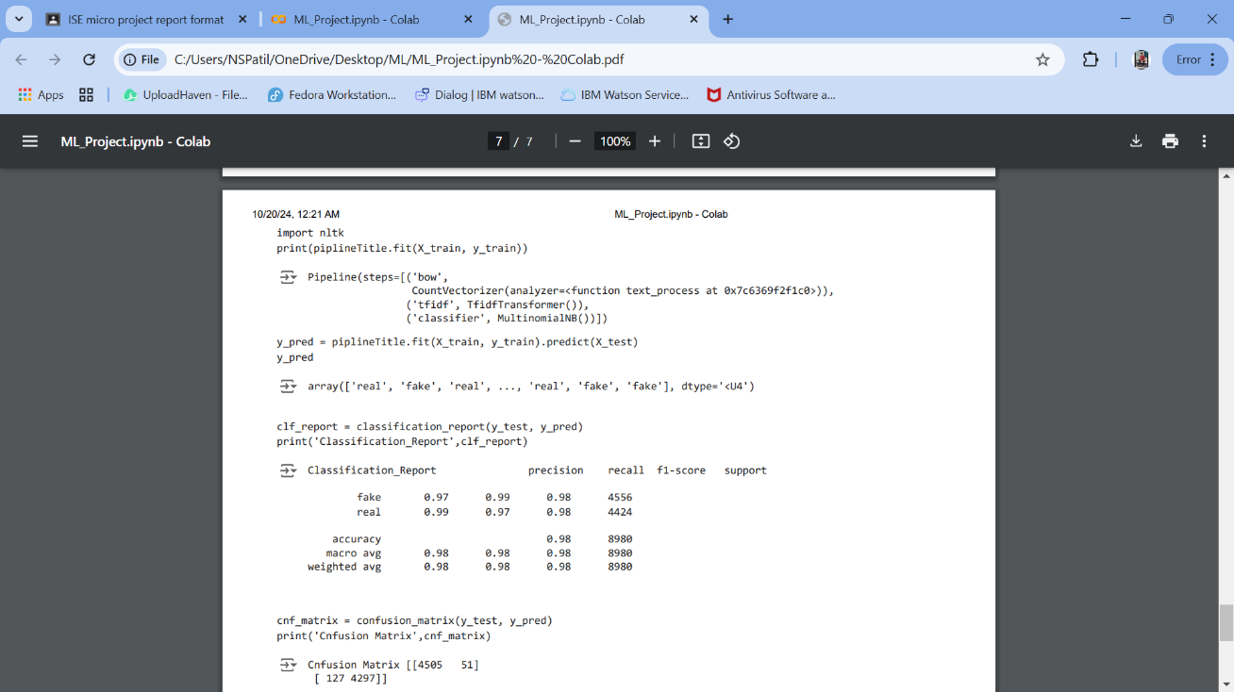

* **Confusion matrix:**

**4505 05**

**127 4297**

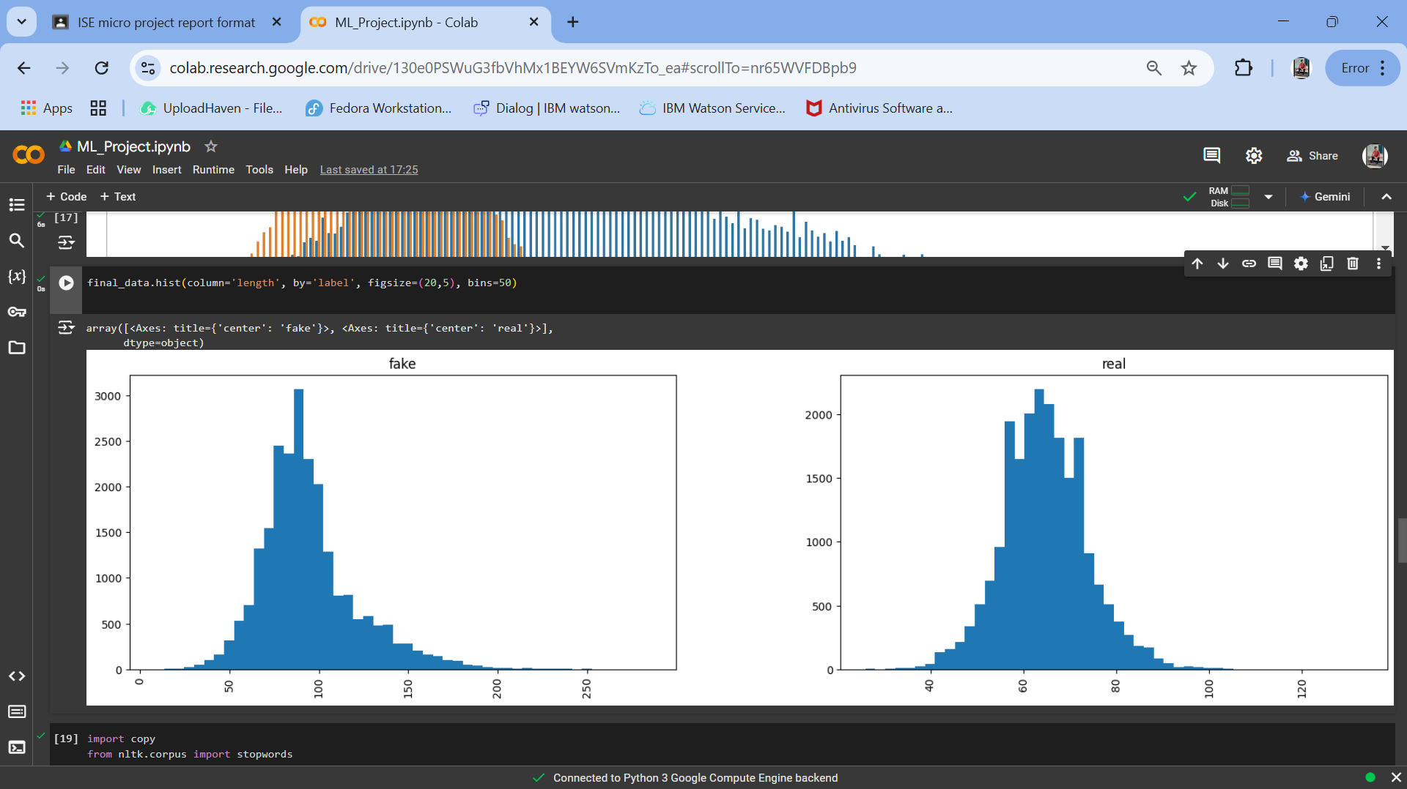

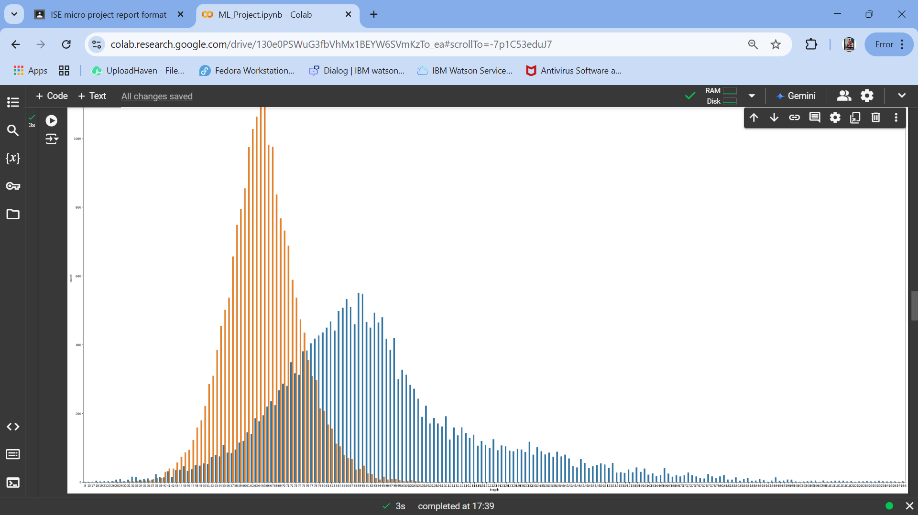

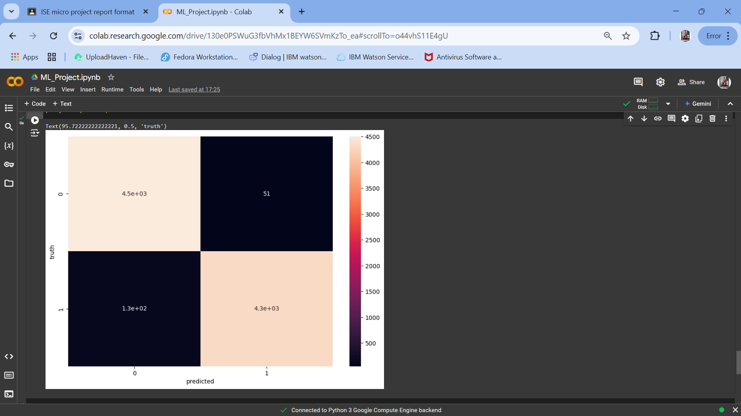

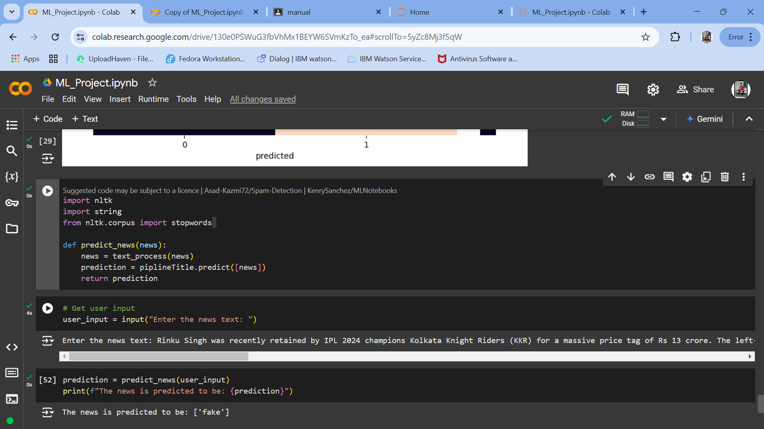

**Discussion**

* The results show that machine learning models, particularly Naïve Bayes model, provide better accuracy than traditional models.
* This aligns with existing literature where ensemble methods outperform single algorithms.
* Challenges encountered include handling missing weather data and ensuring the model did not over fit to historical patterns, especially in emotional approach and the cross words used in news.
* Future research could explore integrating the model supporting with multiple languages. So, it becomes user friendly and creating user friendly GUI.

**Conclusion and Future Considerations**

This project demonstrates that Naïve Bayes is a viable and effective algorithm for fake news detection, achieving 98% accuracy. However, future improvements could include:

* Incorporating deep learning models (LSTM) for better contextual understanding.
* Expanding the dataset to include multiple languages for global applicability.
* Developing a real-time browser extension for fake news detection.
* Enhancing the user interface to make fake news identification accessible for non-technical users.

This study provides a strong foundation for combating misinformation through machine learning techniques.

**References**

[1] S. Gilda, "Notice of Violation of IEEE Publication Principles: Evaluating machine learning algorithms for fake news detection," 2017 IEEE 15th Student Conference on Research and Development (SCOReD), 2017, pp. 110-115, DOI: 10.1109/SCORED.2017.8305411.

[2] M. Granik and V. Mesyura, "Fake news detection using naive Bayes classifier," 2018 IEEE First Ukraine Conference on Electrical and Computer Engineering (UKRCON), 2018, pp. 900-903, DOI: 10.1109/UKRCON.2017.8100379.

[3] Shu, K., Sliva, A., Wang, S., Tang, J., & Liu, H. (n.d.)."fake news detection on social media: A data Mining Perspective".

[4] S. B. Parikh and P. K. Atrey, "Media-Rich Fake News Detection: A Survey," 2018 IEEE Conference on Multimedia Information Processing and Retrieval (MIPR), 2018, pp. 436- 441, DOI: 10.1109/MIPR.2018.00093.

[5] C. Buntain and J. Golbeck, "Automatically Identifying Fake News in Popular Twitter Threads," 2019 IEEE International Conference on Smart Cloud (SmartCloud), 2019, pp. 208-215, DOI: 10.1109/SmartCloud.2017.40.

[6] A. Gupta and R. Kaushal, "Improving spam detection in Online Social Networks," 2021 International Conference on Cognitive Computing and Information Processing(CCIP), 2021, pp. 1-6, DOI: 10.1109/CCIP.2015.7100738.

[7] M. L. Della Vedova, E. Tacchini, S. Moret, G. Ballarin, M. DiPierro, and L. de Alfaro, "Automatic Online Fake News detection Combining Content and Social Signals," 2022 22nd Conference of Open Innovations Association (FRUCT), 2018, pp. 272-279, DOI: 10.23919/FRUCT.2018.846.